**Tutorial: CrimeAR**

**Learning Objectives**

1. How to create Sprite Kit Objects and Node Shapes with ARKit for Augmented Reality.

**Step 0: Earlier Phases of the Software Life Cycle**

We assume that earlier phases of the Software Life Cycle have been completed. See Dr. Balci's [Software Life Cycle](https://manta.cs.vt.edu/cs3714/StudentsOnly/Handouts/SELifeCycle.html). The life cycle processes Problem Formulation, Requirements Engineering, Architecting, and Design are assumed to be completed. In this tutorial, we focus on the Programming process.

**Step 1: Application Functionality Specification**

The CrimeAR app is designed to show you how to use ARKit to build augmented reality experiences. Specifically in this app, two panels will appear to the left and right of the camera view depicting the closest crimes in the area sorted by date as well as the parking location data of the specific area. You would need the users current location to pull in relevant data. We will be using the SpotCrime api (<https://spotcrime.com>) for pulling crimes in the area, and retrieving parking data from Firebase.

Microsoft Word Mockup of Intended Results at a Parking Location on Campus

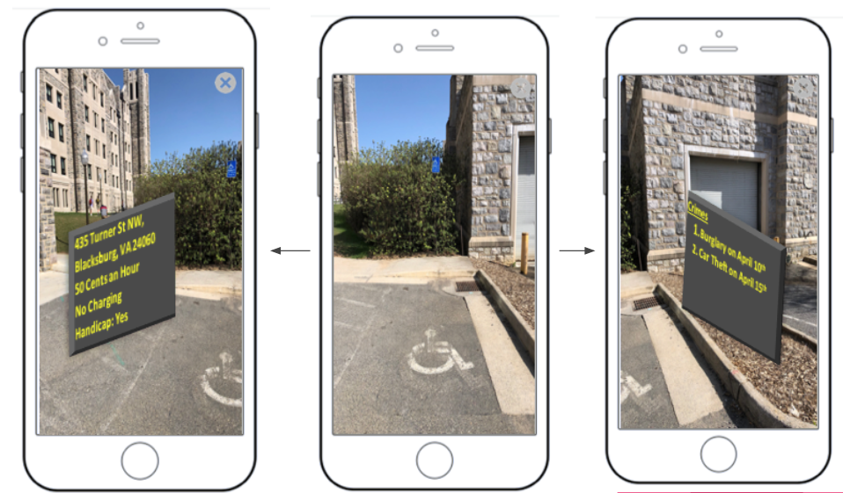

Actual Render of Intended Results at a Parking Location on Campus

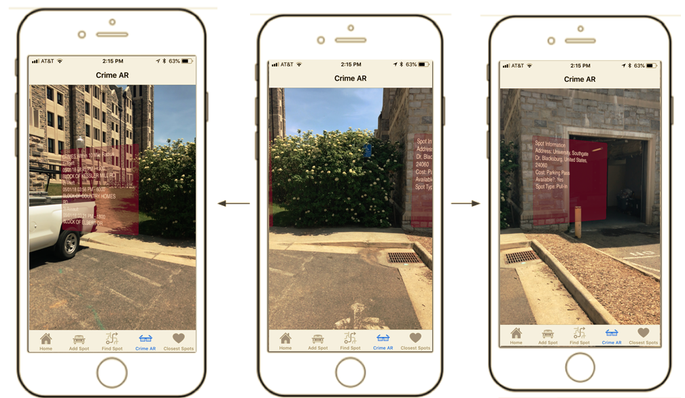

Close Up Pics of AR SKShapeNode View

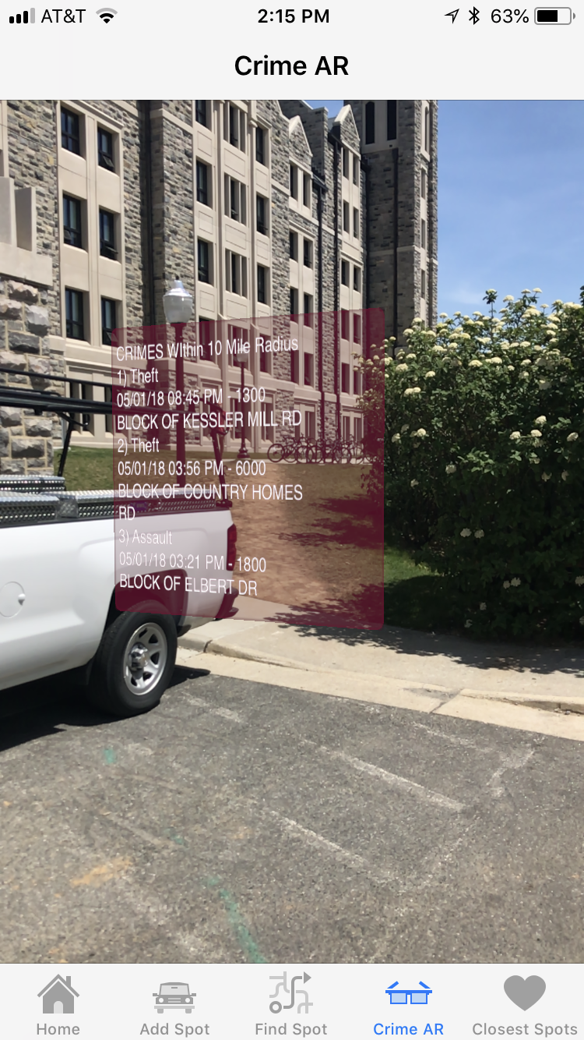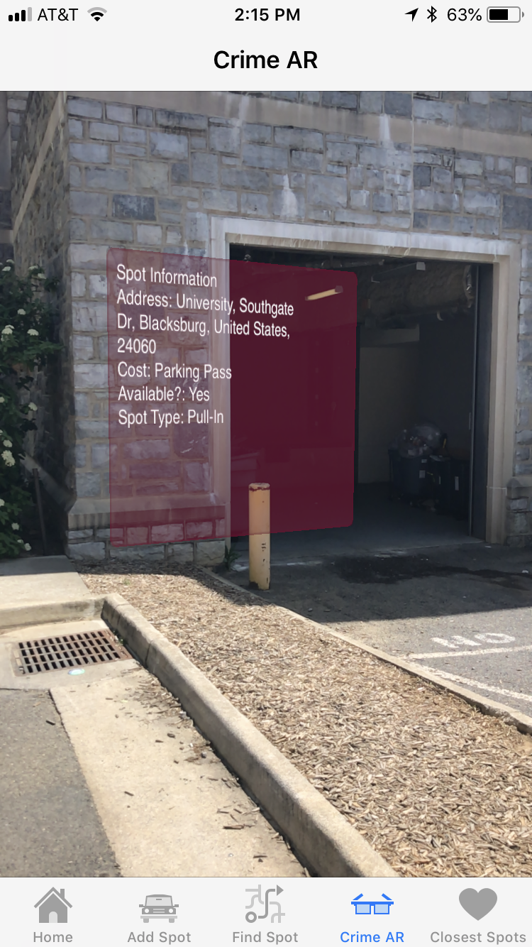

**Step 2: Creation of a New Project**

**Create New Project Folder**

1. Create your new project using the**Single View App**template.
2. Enter *Product Name* as**CrimeAR**
3. Enter *Organization Name* as **YourFirstName YourLastName**
4. Create the app to work on all **iPhone** devices.

Please see table below for compatible devices:

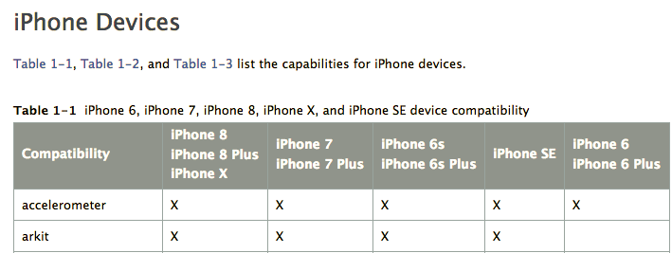

https://developer.apple.com/library/content/documentation/DeviceInformation/Reference/iOSDeviceCompatibility/DeviceCompatibilityMatrix/DeviceCompatibilityMatrix.html

**Assign the Images and Create the Launch Screen**

Assign all imported images and create the launch screen.

**Link Framework**

* CoreLocation.framework
* ARKit.framework

Scroll down to reveal **Linked Frameworks and Libraries** and expand it as shown in the following screenshot.

Click the + (Add) button under the **Linked Frameworks and Libraries** to add a framework as shown below.

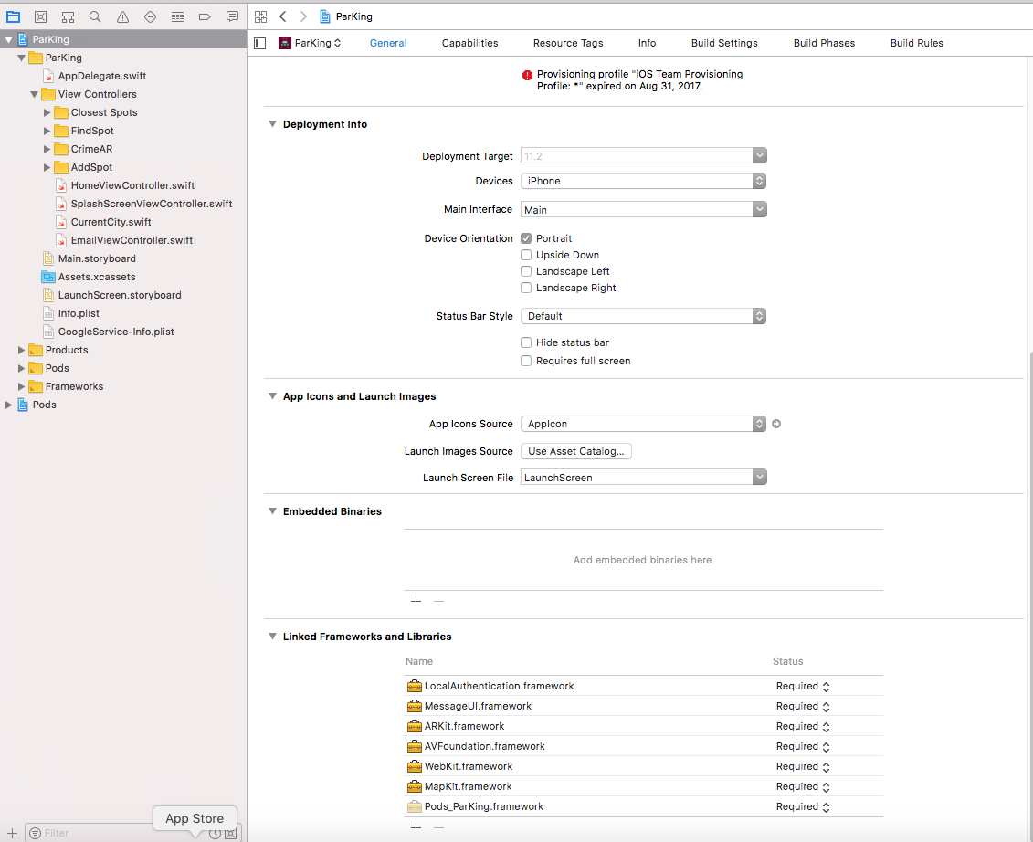

In the *Choose frameworks and libraries to add* dialog, scroll down and click **ARKit.framework** to select it and then click **Add** to add it to your project.

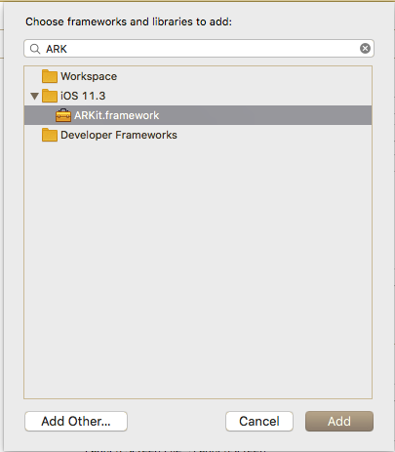

**Step 3: User Interface Development**

The augmented reality nodes will be created programmatically, so in this case, all you would need for user interface development is to add ARKit SceneKit View to your view controller.

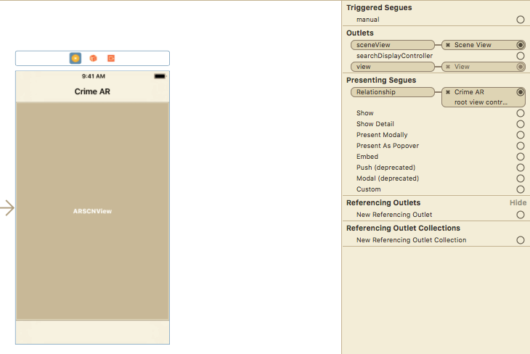

Make sure to add your constraints on this object as well.

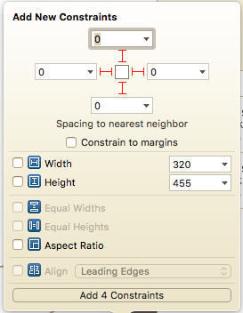

**Step 4: ARKit Class Development**

Now we are all set up on the Storyboard, so we can implement the class file.

Here are the imports that are needed:

import UIKit

import SceneKit

import ARKit

import FirebaseDatabase

import CoreLocation

class CrimeARViewController: UIViewController, ARSCNViewDelegate, CLLocationManagerDelegate {

// ARKit Scene

@IBOutlet var sceneView: ARSCNView!

In the ViewDidLoad function, make sure you also set the delegate

// Set the view's delegate

sceneView.delegate = self

I have included the function that will pull all the relevant data that is needed for augmented reality. I will not be explaining this as the comments within the code does a great job explaining how I got about this and we had done a lot of this in prior Tutorials. This tutorials main focus is to explain how to implement AR.

/*

* Makes the API Calls:

*

* You would need the users current location to pull in relevant data. We will be using the SpotCrime api

* (https://spotcrime.com) for pulling crimes in the area, and retrieving parking data from Firebase.

*/

func crimeDataScraper() {

// Spotcrime API URL

let apiUrl = "http://api.spotcrime.com/crimes.json?lat=\(self.latitudeToPass! as Double)&lon=\(self.longitudeToPass! as Double)&radius=10&key=heythisisforpublicspotcrime.comuse-forcommercial-or-research-use-call-877.410.1607-or-email-pyrrhus-at-spotcrime.com"

let url = URL(string: apiUrl)

let jsonData: Data?

do {

jsonData = try Data(contentsOf: url!, options: NSData.ReadingOptions.mappedIfSafe)

} catch {

return

}

if let jsonDataFromApiUrl = jsonData {

do {

let jsonDataDictionary = try JSONSerialization.jsonObject(with: jsonDataFromApiUrl, options: JSONSerialization.ReadingOptions.mutableContainers) as? NSDictionary

// Typecast the returned NSDictionary as Dictionary<String, AnyObject>

let dictionaryOfCountryJsonData = jsonDataDictionary! as! Dictionary<String, Any>

let crimeData = dictionaryOfCountryJsonData["crimes"] as! NSArray as! [Any]

var count = 0

for (item) in crimeData {

// set data as a Dictionary

let data = item as! NSDictionary

// prevalent data

let type = data["type"] as! String

let date = data["date"] as! String

let address = data["address"] as! String

let crimeData = [type, date, address]

// append all crimes within 10 miles to dict

dict_Theft_Data[count] = crimeData as NSArray

count+=1

}

} catch let error as NSError {

print (error)

return

}

}

// retrieves the Firebase Database Reference

ref = Database.database().reference()

// iterates through the parking spots within the current city

ref.child(currentCity.city).observeSingleEvent(of: .value, with: { (snapshot) in

let spots: [Any] = snapshot.value as! [Any] // gets the list of parking spots

var coordinates = [CLLocationCoordinate2D]() // will store all of the coordinates from the parking spots

let currentLocation = CLLocation(latitude: self.latitudeToPass! as Double, longitude: self.longitudeToPass! as Double) // sets the current location

// iterates through the list of spots

for spot in spots {

// sets each spot as a dict

let obj = spot as! Dictionary<String, Any>

// creates a CLLocationCoordinate2D object from the latitude and longitude of the spot

let centerLocation = CLLocationCoordinate2D(latitude: obj["latitude"] as! Double, longitude: obj["longitude"] as! Double)

//appends these coordinates to an array

coordinates.append(centerLocation)

}

// iterate through all of the coordinates, and order them based on how far they are from the

// users current location

let sortedCoordinates = coordinates.map({CLLocation(latitude: $0.latitude, longitude: $0.longitude)}).sorted(by: {

$0.distance(from: currentLocation) < $1.distance(from: currentLocation)

})

// again iterate through the list of spots

for spot in spots {

// sets each spot as a dict

let obj = spot as! Dictionary<String, Any>

// if the closest spot to the users location is equal to the iterated spot, set that as the parking

// spot to display

if (obj["longitude"] as! Double == sortedCoordinates[0].coordinate.longitude && obj["latitude"] as! Double == sortedCoordinates[0].coordinate.latitude) {

self.parkingSpot = obj

}

}

// Sets the AR View for Parking Location Data

self.spotLocation()

// Sets the AR View for Crime Data

self.crimeLocation()

}) { (error) in

print(error.localizedDescription)

}

}

The two functions below contain all the information needed to create this AR experience. The comments themselves do a great job with explain what is going on. Some things to elaborate on are the different types of building blocks to AR. The SKNode class is the fundamental building block of most SpriteKit content. I will detail the list of all of the nodes used below taken from Apples Developer Page:

SKScene: The root node for all Sprite Kit objects displayed in a view.

SKShapeNode: A node that renders a shape defined by a Core Graphics path.

The data (SkLabelNode) will be displayed on top of this, but this node itself is transparent.

SKLabelNode: A node that displays a text label.

This contains all the data as a String taken from either the Crime API or Firebase

SCNPlane: A rectangular, one-sided plane geometry of specified width and height.

This is what the text will be shown in front of

SCNMaterial: A set of shading attributes that define the appearance of a geometry's surface when rendered.

This is how the plane will be textured.

SCNNode: A structural element of a scene graph, representing a position and transform in a 3D coordinate space, to which you can attach geometry, lights, cameras, or other displayable content.

SCNNode will contain the plain

/*

* ARView for Spot Information

*/

func spotLocation() {

// The root node for all Sprite Kit objects displayed in a view

let skScene = SKScene(size: CGSize(width: 400, height: 300))

skScene.backgroundColor = UIColor.clear

// the panel that data will be written on top of

let rectangle = SKShapeNode(rect: CGRect(x: 0, y: 0, width: 400, height: 300), cornerRadius: 10)

rectangle.fillColor = colorLiteral(red: 0.807843148708344, green: 0.0274509806185961, blue: 0.333333343267441, alpha: 1.0)

rectangle.strokeColor = colorLiteral(red: 0.439215689897537, green: 0.0117647061124444, blue: 0.192156866192818, alpha: 1.0)

rectangle.lineWidth = 5

rectangle.alpha = 0.4

let geocoder = CLGeocoder()

// retrieve the current location

let centerLocation = CLLocation(latitude: parkingSpot!["latitude"] as! Double, longitude: parkingSpot!["longitude"] as! Double)

// Look up the location and pass it to the completion handler

geocoder.reverseGeocodeLocation(centerLocation, completionHandler: { (placemarks, error) in

if error == nil {

// reverse geocoding to retrieve the data to populate the address string

let pm = placemarks! as [CLPlacemark]

if pm.count > 0 {

let pm = placemarks![0]

var addressString : String = ""

if pm.subLocality != nil {

addressString = addressString + pm.subLocality! + ", "

}

if pm.thoroughfare != nil {

addressString = addressString + pm.thoroughfare! + ", "

}

if pm.locality != nil {

addressString = addressString + pm.locality! + ", "

}

if pm.country != nil {

addressString = addressString + pm.country! + ", "

}

if pm.postalCode != nil {

addressString = addressString + pm.postalCode! + " "

}

// Once the address is found, output the spot information

// to String temp

var spot_information = "Spot Information\n"

spot_information += "Address: " + addressString + "\n"

spot_information += "Cost: " + (self.parkingSpot!["cost"] as! String) + "\n"

spot_information += "Available?: " + (self.parkingSpot!["availability"] as! Bool ? "Yes" : "No" ) + "\n"

spot_information += "Spot Type: " + (self.parkingSpot!["spotType"] as! String) + "\n"

// A node that displays a text label

let labelNode = SKLabelNode()

labelNode.text = spot_information

labelNode.lineBreakMode = NSLineBreakMode.byWordWrapping

labelNode.numberOfLines = 10

labelNode.preferredMaxLayoutWidth = 300

labelNode.fontSize = 20

labelNode.fontName = "San Fransisco"

labelNode.position = CGPoint(x:150,y:120)

skScene.addChild(rectangle) // add the display panel to the scene

skScene.addChild(labelNode) // add the text label to the scene

// this makes the panel more visually appealing

let plane = SCNPlane(width: 20, height: 20)

// A set of shading attributes that define the appearance of a geometry's

// surface when rendered

let material = SCNMaterial()

material.isDoubleSided = true

material.diffuse.contents = skScene

material.diffuse.contentsTransform = SCNMatrix4Translate(SCNMatrix4MakeScale(1, -1, 1), 0, 1, 0)

plane.materials = [material]

// A structural element of a scene graph, representing a position and transform

// in a 3D coordinate space, to which you can attach geometry, lights, cameras, or other

// displayable content.

let node = SCNNode(geometry: plane)

node.position = SCNVector3(x: 25, y: 0, z: -50)

// add the node to the main view

self.sceneView.scene.rootNode.addChildNode(node)

}

}

})

}

/*

* ARView for Crime Information

*/

func crimeLocation() {

// The root node for all Sprite Kit objects displayed in a view

let skScene = SKScene(size: CGSize(width: 400, height: 300))

skScene.backgroundColor = UIColor.clear

// the panel that data will be written on top of

let rectangle = SKShapeNode(rect: CGRect(x: 0, y: 0, width: 400, height: 300), cornerRadius: 10)

rectangle.fillColor = colorLiteral(red: 0.807843148708344, green: 0.0274509806185961, blue: 0.333333343267441, alpha: 1.0)

rectangle.strokeColor = colorLiteral(red: 0.439215689897537, green: 0.0117647061124444, blue: 0.192156866192818, alpha: 1.0)

rectangle.lineWidth = 5

rectangle.alpha = 0.4

// Get the most recent crime data within a 10 mile radius from the users current location

var temp = "CRIMES WIthin 10 Mile Radius\n"

temp += "1) " + (dict_Theft_Data[0]![0] as! String) + "\n" + (dict_Theft_Data[0]![1] as! String) + " - " + (dict_Theft_Data[0]![2] as! String) + "\n"

temp += "2) " + (dict_Theft_Data[1]![0] as! String) + "\n" + (dict_Theft_Data[1]![1] as! String) + " - " + (dict_Theft_Data[1]![2] as! String) + "\n"

temp += "3) " + (dict_Theft_Data[2]![0] as! String) + "\n" + (dict_Theft_Data[2]![1] as! String) + " - " + (dict_Theft_Data[2]![2] as! String) + "\n"

// A node that displays a text label

let labelNode = SKLabelNode()

labelNode.text = temp

labelNode.lineBreakMode = NSLineBreakMode.byWordWrapping

labelNode.numberOfLines = 10

labelNode.preferredMaxLayoutWidth = 300

labelNode.fontSize = 20

labelNode.fontName = "San Fransisco"

labelNode.position = CGPoint(x:150,y:20)

skScene.addChild(rectangle) // add the display panel to the scene

skScene.addChild(labelNode) // add the text label to the scene

// this makes the panel more visually appealing

let plane = SCNPlane(width: 20, height: 20)

// A set of shading attributes that define the appearance of a geometry's

// surface when rendered

let material = SCNMaterial()

material.isDoubleSided = true

material.diffuse.contents = skScene

material.diffuse.contentsTransform = SCNMatrix4Translate(SCNMatrix4MakeScale(1, -1, 1), 0, 1, 0)

plane.materials = [material]

// A structural element of a scene graph, representing a position and transform

// in a 3D coordinate space, to which you can attach geometry, lights, cameras, or other

// displayable content.

let node = SCNNode(geometry: plane)

node.position = SCNVector3(x: -25, y: 0, z: -50)

// add the node to the main view

sceneView.scene.rootNode.addChildNode(node)

}

After adding these code bits, you should have a functioning AR experience!